ID NUMBER: 22424252
ASTA 607 (COMPUTATIONAL STATISTICS 1)
QUESTION 1
# a.
library(MASS)
?crabs
# Crabs has 200 row observations and 8 columns.
# The source of data is Campbell, N.A. and Mahom, R.J. (1974)
dim(crabs)

# b.
data(crabs)
str(crabs)

#c.
table(crabs$sp)
table(crabs$sex)

# d.
summarise_group <- table(crabs$sp, crabs$sex)
barplot(summarise_group, xlab="Species data", ylab = "Sex data",
main="Summary of group composition", col=1:2)
?barplot

# QUESTION 1
> # a.
> ?crabs
> # b.
> data(crabs)
> str(crabs)
'data.frame': 200 obs. of 8 variables:
$ sp : Factor w/ 2 levels "B","O": 1 1 1 1 1 1 1 1 1 1 ...
$ sex : Factor w/ 2 levels "F","M": 2 2 2 2 2 2 2 2 2 2 ...
$ index: int 1 2 3 4 5 6 7 8 9 10 ...
$ FL : num 8.1 8.8 9.2 9.6 9.8 10.8 11.1 11.6 11.8 11.8 ...
$ RW : num 6.7 7.7 7.8 7.9 8 9 9.9 9.1 9.6 10.5 ...
$ CL : num 16.1 18.1 19 20.1 20.3 23 23.8 24.5 24.2 25.2 ...
$ CW : num 19 20.8 22.4 23.1 23 26.5 27.1 28.4 27.8 29.3 ...
$ BD : num 7 7.4 7.7 8.2 8.2 9.8 9.8 10.4 9.7 10.3 ...
> #c.
> table(crabs$sp)

B O
100 100
> table(crabs$sex)

F M
100 100
> # d.
> summarise_group <- table(crabs$sp, crabs$sex)
> barplot(summarise_group, xlab="Species data", ylab = "Sex data",
+ main="Summary of group composition", col=1:2)
> ?barplot
> # QUESTION 2a.
> par(mfrow=c(1,2))

>

- Crabs dataset has 200 row observations and 8 columns. The source of data is Campbell, N.A. and Mahom, R.J. (1974). It has five numeric values, one integer , and two factor variables.
e. The dataset is balanced across four groups because all the bar charts have the same height.
QUESTION 2
par(mfrow=c(1,2))
par(mar=c(4,4,3,3))
x <- crabs$BD
y <- crabs$sp
z <- crabs$sex
boxplot(x~y, xlab = "Species", ylab = "Frequency",
main="BD defined by Species", col=1:2)
boxplot(x~z, xlab = "Sex", ylab = "Frequency",
main = "BD defined by sex", col=3:4)

# QUESTION 2b.

central_tendency <- crabs %>% group_by(sp, sex) %>%
summarise(Mean=mean(summarise_group),
Median=median(summarise_group),
Mode=as.numeric(names(which.max(table(summarise_group)))),
.groups = "drop")
central_tendency

variability <- crabs %>% group_by(sp, sex) %>%
reframe(Variance=var(summarise_group),
SD=sd(summarise_group),
IQR=IQR(summarise_group),
Range=max(summarise_group)-min(summarise_group))
variability

# QUESTION 2a.
> par(mfrow=c(1,2))
> par(mar=c(4,4,3,3))
> x <- crabs$BD
> y <- crabs$sp
> z <- crabs$sex
> boxplot(x~y, xlab = "Species", ylab = "Frequency",
+ main="BD defined by Species", col=1:2)
> boxplot(x~z, xlab = "Sex", ylab = "Frequency",
+ main = "BD defined by sex", col=3:4)
> # QUESTION 2b.
> # From our graph, we see that there are no
> # outliers for both species and sex
> central_tendency <- crabs %>% group_by(sp, sex) %>%
+ summarise(Mean=mean(summarise_group),
+ Median=median(summarise_group),
+ Mode=as.numeric(names(which.max(table(summarise_group)))),
+ .groups = "drop")
> central_tendency
# A tibble: 4 × 5
sp sex Mean Median Mode
<fct> <fct> <dbl> <dbl> <dbl>
1 B F 50 50 50
2 B M 50 50 50
3 O F 50 50 50
4 O M 50 50 50
> # From the above, we see that mean=median=mode between the groups
> variability <- crabs %>% group_by(sp, sex) %>%
+ reframe(Variance=var(summarise_group),
+ SD=sd(summarise_group),
+ IQR=IQR(summarise_group),
+ Range=max(summarise_group)-min(summarise_group))
> variability
# A tibble: 8 × 6
sp sex Variance[,1] [,2] SD IQR Range
<fct> <fct> <dbl> <dbl> <dbl> <dbl> <int>
1 B F 0 0 0 0 0
2 B F 0 0 0 0 0
3 B M 0 0 0 0 0
4 B M 0 0 0 0 0
5 O F 0 0 0 0 0
6 O F 0 0 0 0 0
7 O M 0 0 0 0 0
8 O M 0 0 0 0 0

- From our graph, we see that there are no outliers for both species and sex.
From the above, we see that mean=median=mode between the groups.
From this we can see that none of the groups have higher variability than the other. Variability is 0 for each group.
QUESTION 3
QUESTION 3
# a.
par(mar=c(4,4,3,3))
hist(crabs$CL[crabs$sp== "B"],
xlab = "Carapace length for blue species (in mm)",
ylab = "Frequency",
main = "Histogram of carapace length for blue species",
col = 1:8)
hist(crabs$CL[crabs$sp== "O"],
xlab = "Carapace length for orange species (in mm)",
ylab = "Frequency",
main = "Histogram of carapace length for orange species",
col = 9:16)

QUESTION 3
> # a.
> par(mar=c(4,4,3,3))
> hist(crabs$CL[crabs$sp== "B"],
+ xlab = "Carapace length for blue species (in mm)",
+ ylab = "Frequency",
+ main = "Histogram of carapace length for blue species",
+ col = 1:8)
> hist(crabs$CL[crabs$sp== "O"],
+ xlab = "Carapace length for orange species (in mm)",
+ ylab = "Frequency",
+ main = "Histogram of carapace length for orange species",
+ col = 9:16)

Question 3.b.
b.
For histogram of carapace length for blue species, we see that it is approximately symmetric. We also see that it is unimodal.
That is, it contains only one mode.
However, for histogram of carapace length for orange species, we see
that it is left-skewed. It also has one mode and so, it is unimodal.
QUESTION 4
?crabs
mean_of_FL <- crabs %>% mean(crabs$FL[crabs$sp=="B"])

summarise(Mean=mean(crabs$FL),
.groups = "drop")
mean_of_RW <- crabs %>% group_by(sp,sex) %>%
summarise(Mean=mean(crabs$RW),
.groups = "drop")
mean_of_CL <- crabs %>% group_by(sp,sex) %>%
summarise(Mean=mean(crabs$CL),
.groups = "drop")
mean_of_CW <- crabs %>% group_by(sp,sex) %>%
summarise(Mean=mean(crabs$CW),
.groups = "drop")
mean_of_BD <- crabs %>% group_by(sp,sex) %>%
summarise(Mean=mean(crabs$BD),
.groups = "drop")
barplot(mean_of_FL, xlab = "d", ylab = "f", main = "r")
?barplot
barplot(mtcars$mpg)

QUESTION 5
pairs_plot <- crabs[,c("FL", "RW", "CL", "CW", "BD" )]
pairs(pairs_plot)

# QUESTION 5
> pairs_plot <- crabs[,c("FL", "RW", "CL", "CW", "BD" )]
> pairs(pairs_plot)

>

QUESTION 5B
From above figure, we see that among variables, there is positive relationship among them. This means an increase in one variable leads to increase in the other variable.

QUESTION 6
CRABS DATA SET
Introduction
The crabs dataset is within the MASS package within R. Crabs dataset has 200 row observations and 8 columns. The source of data is Campbell, N.A. and Mahom, R.J. (1974). It has five numeric values, one integer , and two factor variables. From figure A, The dataset is balanced across four groups because all the bar charts have the same height. Crabs dataset has 200 row observations and 8 columns. It has five numeric values, one integer , and two factor variables. The dataset is balanced across four groups because all the bar charts have the same height.

Body
FIGURE A FOR QUESTION 1
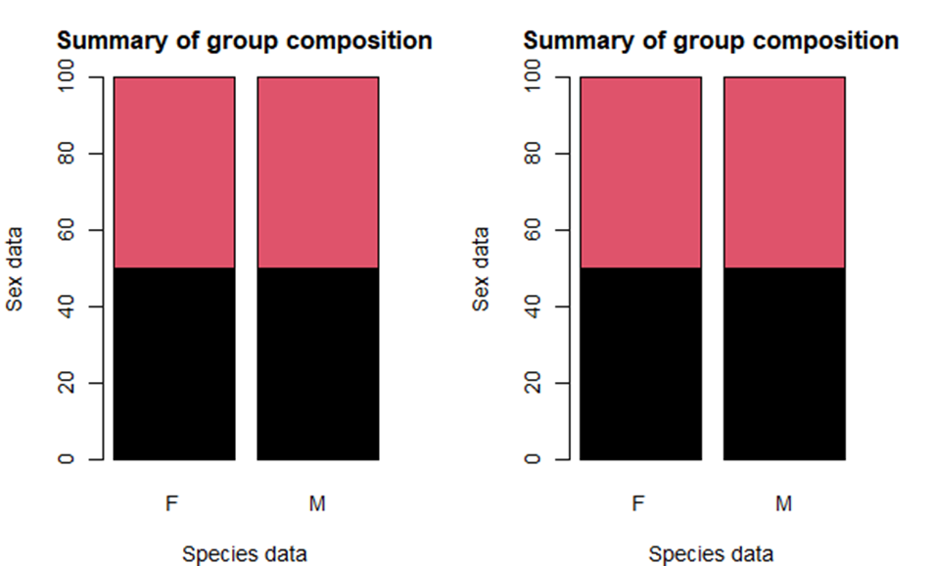

FIGURE B FOR QUESTION 2

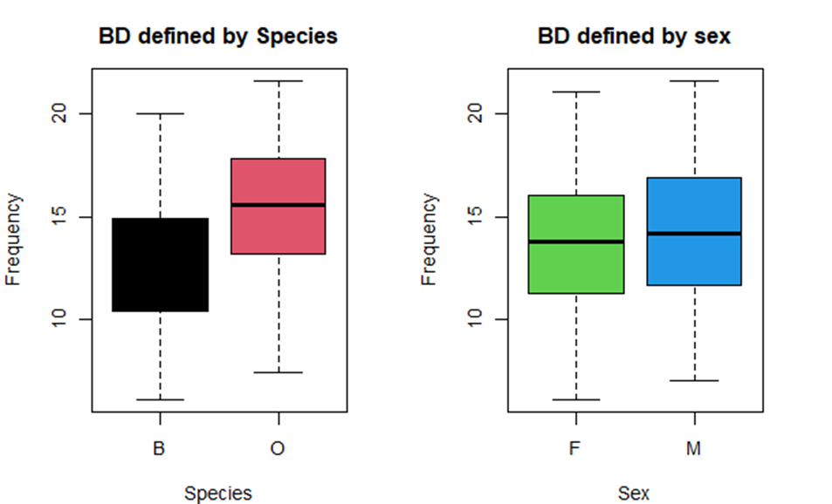

From our figure B, we see that there are no outliers for both species and sex.
From the above, we see that mean=median=mode between the groups. From this we can see that none of the groups have higher variability than the other. Variability is 0 for each group.
FIGURE C FOR QUESTION 3
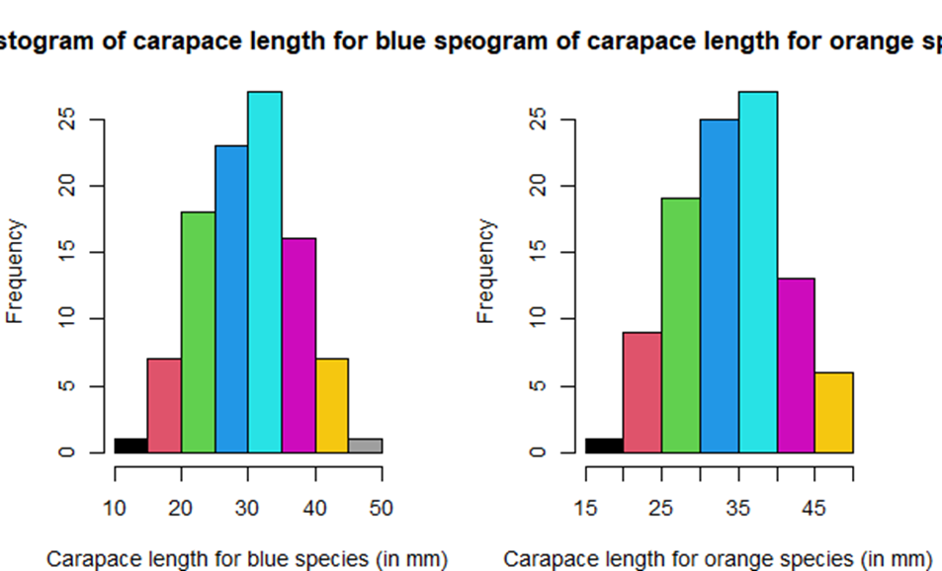

From figure C, for histogram of carapace length for blue species, we see that it is approximately symmetric. We also see that it is unimodal.
That is, it contains only one mode.
However, for histogram of carapace length for orange species, we see
that it is left-skewed. It also has one mode and so it is unimodal.

FIGURE E FOR QUESTION 5
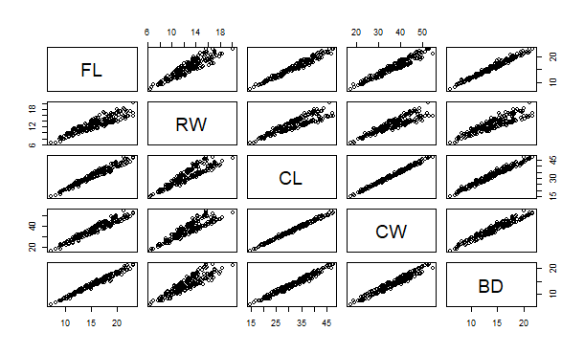

From above figure, we see that among variables, there is positive relationship among them. This means an increase in one variable leads to increase in the other variable. This means the various pairs all have a strong relationship.
Conclusion
Within species and sex, dataset is balanced across the four groups. For body depth for four groups defined by species and sex, there are not outliers and mean=median=mode. Moreover, with histogram of carapace length for blue species, we see that it is approximately symmetric. We also see that it is unimodal. Lastly, there is positive relationship between the various pairs of the five measurements and this means the various pairs all have a strong relationship.

